**PMSaaS**

Project Management

Software as a Service

**Guide**



Index

1. Introduction 3

2. Installation 3

3. Pages 5

3.1. Overview 5

3.1.1. Your Projects 5

3.1.2. Other Projects 5

3.1.3. Archived Projects 5

3.2. Project Overview 5

3.2.1. Budget 5

3.2.2. Effort 6

3.2.3. Workpackages & Tasks 6

3.2.4. Share/Edit/Archive Project 7

3.3. New Project 7

3.4 New Employee 8

3.5. My Profile 8

3.6. Admin 8

3.6.1. Change Logo 8

3.6.2. Edit Employees 8

3.6.3. Edit Projects 9

# 1. Introduction

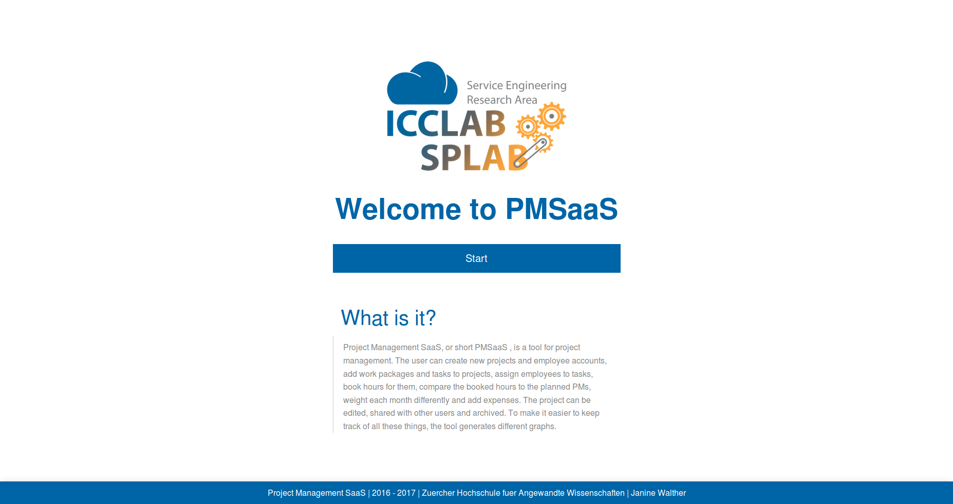

Project Management SaaS, or short PMSaaS, is a tool for project management.   
The user can create new projects and employee accounts, add work packages   
and tasks to projects, assign employees to tasks, book hours for them,   
compare the booked hours to the planned PMs, weight each month differently   
and add expenses. The project can be edited, shared with other users and   
archived. To make it easier to keep track of all these things, the tool   
generates different graphs.

# 2. Installation

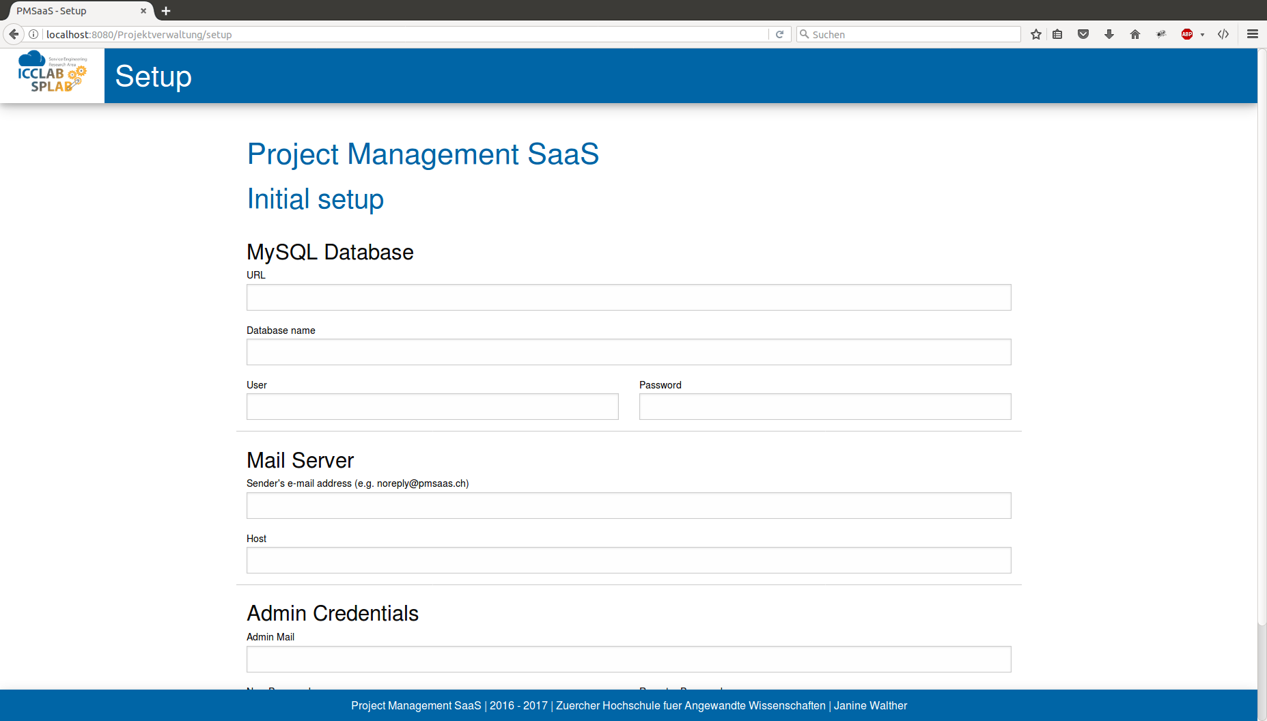For installing PMSaaS you need Tomcat, MySQL and an e-mail server. The setup part of PMSaaS will create a database for you, so you only need to have a server with MySQL for that part.

In the initial setup of PMSaaS, you will be asked for your database, your mail server and the e-mail address and password of the admin. Fill in the URL of your database (including the port) and then choose a name for your database. It can be anything, just make sure it does not exist on your MySQL server yet. Then you have to fill in your MySQL login credentials.

Next step is your e-mail server. Choose the address e-mails should be sent from and the URL of your server. 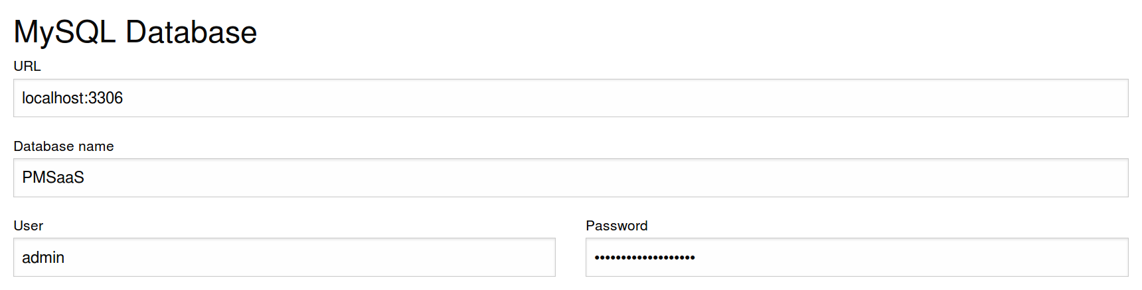

For the last step, fill in the admin's e-mail address and choose a password. 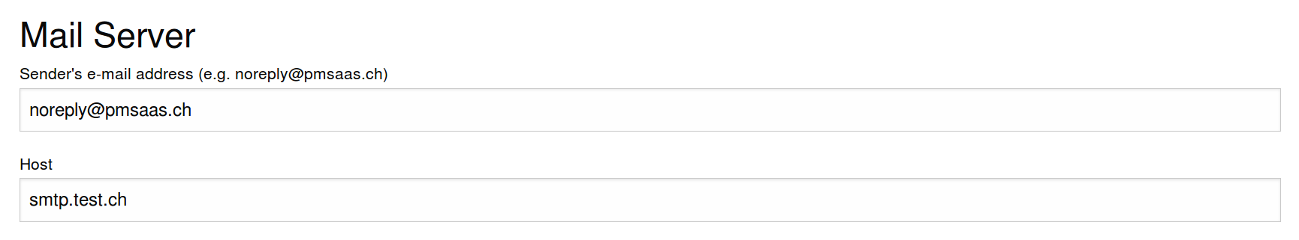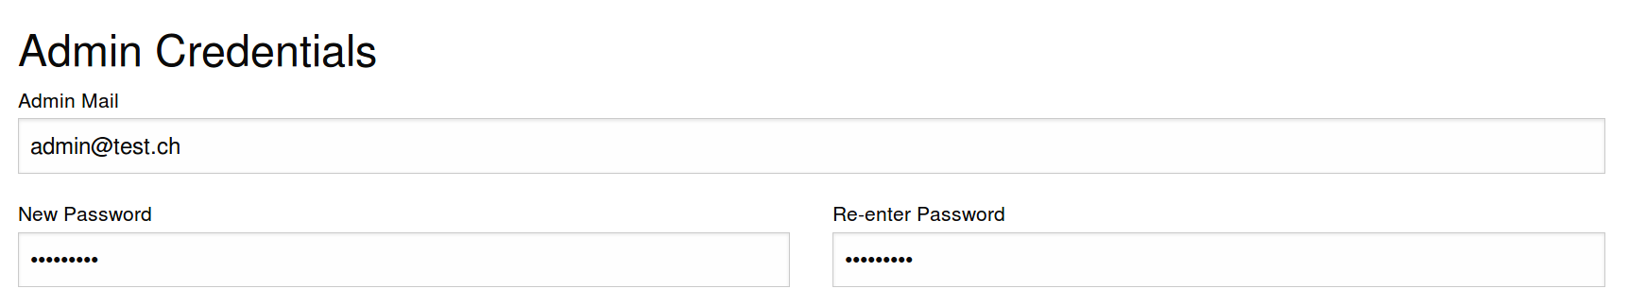

Click on the submit button and PMSaaS is ready!

# 3. Pages

## 3.1. Overview

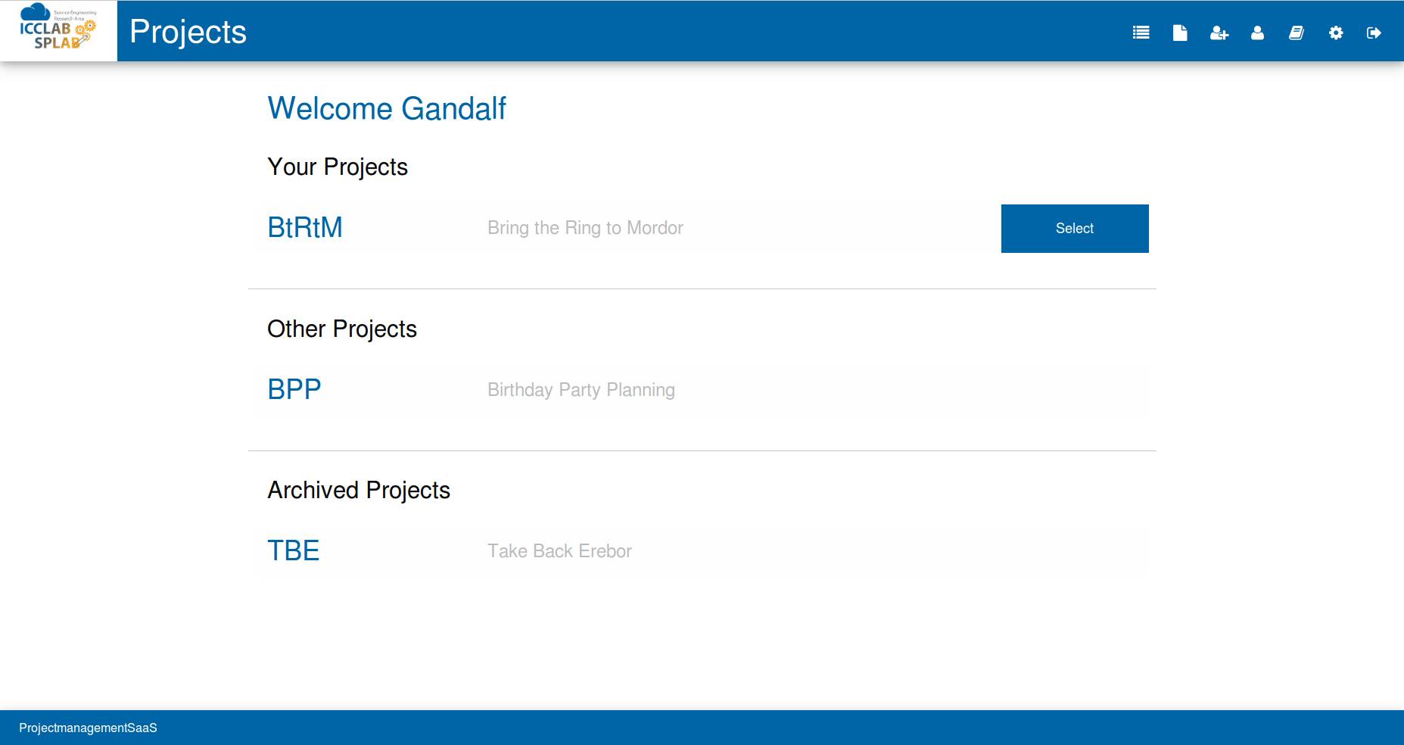

On the Overview page, you can see your projects, projects others shared with you and your archived projects. If there are no projects shared with you or no archived projects, you won’t see these categories.

### 3.1.1. Your Projects

You will see a list with every project you created, and that is not archived. After clicking on the name of the project you can see more details about it. These are the same details, that someone, with whom you shared the project, can see.

### 3.1.2. Other Projects

“Other Projects” means projects, that someone has shared with you. First, you see the owner of the project and then the other details. You can see the details of these projects, but you cannot add, edit or delete data.

### 3.1.3. Archived Projects

Here you will find your archived projects. You can see the details of the project but not edit it. If you have to edit something, you have to ask your admin to restore it.

## 3.2. Project Overview

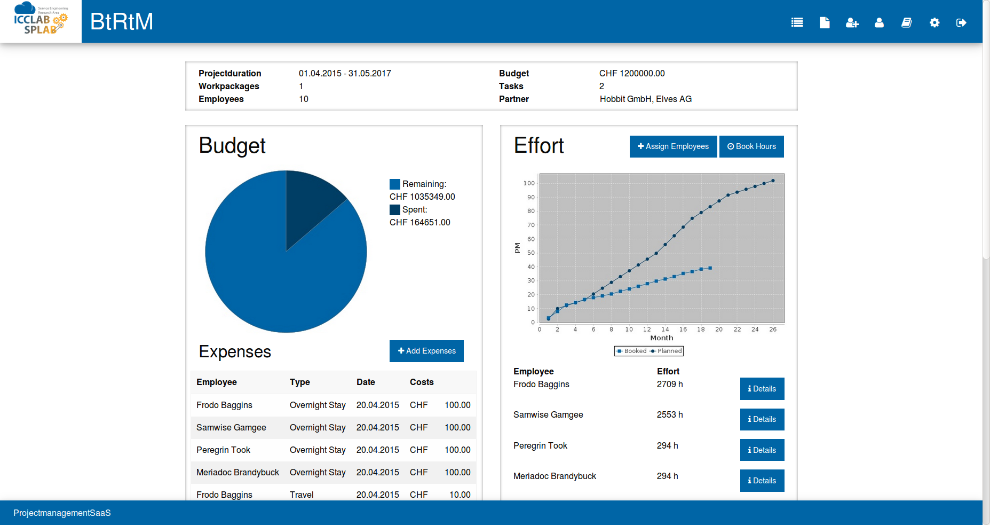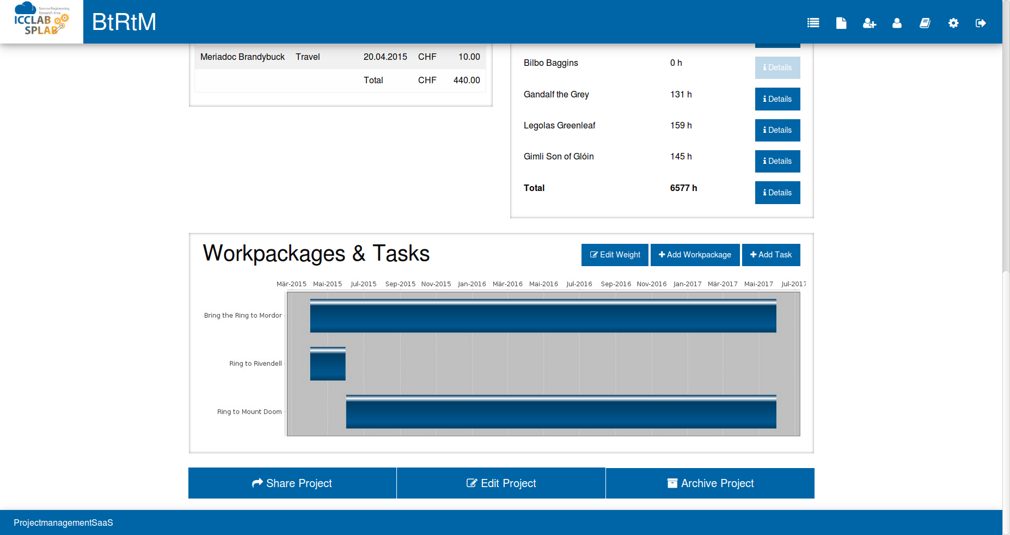

On the project overview page, you will find panels to monitor the budget, the effort and the work packages and tasks. You can add expenses, assign employees, book hours, add work packages and tasks, set a weight for every month, share, edit and archive your project. Different graphs arrange your data for a quicker and easier overview.

### 3.2.1. Budget

A pie chart on the budget panel shows how much of your budget was spent and how much is left. Below this, you will see a table with all your expenses. Place your cursor on the type field to see the description of the expense.

#### 3.2.1.1. Add expenses

After a click on the Add Expenses button you can create a new expense for one of your employees (or yourself). Fill in all the fields and add a good description for better recognition. Click on the Add Expense button and your expense will be added to the project.

### 3.2.2. Effort

The effort panel shows you the booked effort of your project, compared to your planned one in a line chart. Further you see every one of the assigned employees and how many hours they booked on the project. At the bottom, there is a total of all hours booked. To get a more detailed view of the effort you can click on the Details button next to the employee you like to see or the one next to the total effort.

#### 3.2.2.1. Assign employees

Employees must be assigned to a task before you can book hours for them. To do this, you can click on the Assign Employees button on the top of the effort panel. After that, you will be asked to choose an employee. Choose your employee from the list and click on the button Choose Task. After tis you'll see a list of all tasks where your employee is not assigned yet. You can choose multiple tasks and assign your employee to these with clicking on the Assign button.

#### 3.2.2.2. Book hours

You can book hours for your employees with a click on the Book Hours button. The tool asks you to choose an employee from the list. After clicking on Choose Task you'll see a list of all tasks the employee is assigned to. Choose one or more tasks and click on Hours. On the next page, you can fill in how many hours there were and for which month you want to book them.

#### 3.2.2.3. Details specific employee

If you click on the Details button next to an employee, you can get detailed information about the effort of this specific employee. First you see a line chart with the booked hours per month. Below that, you have a detailed list about every month where the employee has booked some hours. You see on which task they were booked and the costs.

#### 3.2.2.4. Details all employees

This page is very like the details page for a specific employee, but here you have the chart from the project overview page as a bigger image and the list contains the hours booked by all employees and all tasks.

### 3.2.3. Workpackages & Tasks

The Workpackages & Tasks panel lets you have a look on all your work packages and the tasks. If you must add a new work package or task, you can do it here. If needed, a different weight for each month and task can be set here.

#### 3.2.3.1. Edit weight

To set a different weight for each month, click on the Edit Weight button. You will see a list with every task and every month. Now you can set a different weight for every month. With a click on the button Edit Weight you can save all changes.

#### 3.2.3.2. Add work package

After a click on the Add Work package button you can create a new work package. Make sure that the start and end date are within the start and end date of the project.

#### 3.2.3.3. Add task

By clicking on the Add Task button you can add a new task to your project. Define the name, start and end date, number of PMs, your budget for this task and choose the work package this task belongs to. Make sure that the start and end date are within the start and end date of the work package.

### 3.2.4. Share/Edit/Archive Project

On the bottom of the page you have three buttons: Share Project, Edit Project and Archive Project.

#### 3.2.4.1. Share Project

If someone else should have access to the data of your project, you can share it with this person. The person will be able to see everything but cannot edit something. Click on the button and choose the employees you want to share the project with. You can choose as many as you want.

#### 3.2.4.2. Edit Project

If you made a mistake or something has changed, you can easily edit your project with a click on the Edit Project button. On this page, you can edit or delete nearly everything. The only thing you can't delete is your project (if you'd like to delete it you must talk to the admin, he can delete it for you). Don't forget to apply your changes!

#### 3.2.4.3. Archive Project

If your project is finished and you want to have a better overview, you can archive your project. Please notice that you can't restore the project by yourself and you must talk to the admin if you need it back. You will only see the most important details of an archived project, like name, duration, total budget, amount of work packages and tasks, which employees worked on it and with which partners you realised the project.

## 3.3. New Project

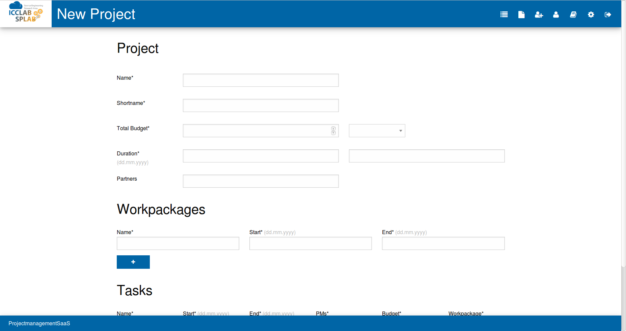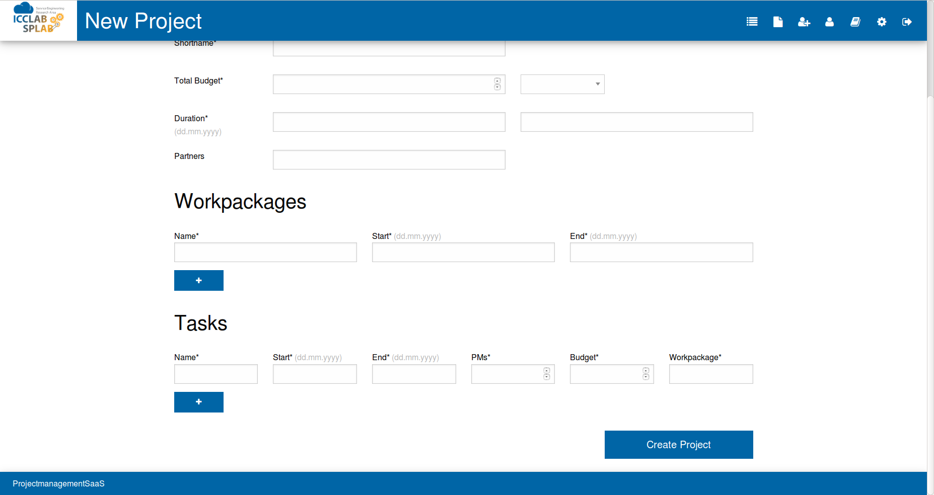You can create a new project by clicking on the  button. Fill in the fields and make sure the dates are correct. You can add as many work package and tasks as you want, but you must have at least once of each. If your project doesn’t have work packages you must make a work package with the same name and date like your task. In this way, the Gantt chart on the project overview page will only show the task and no work packages. You will be asked for a work package for each task. Write here the name of your work package, make sure the writing is correct.

## 3.4 New Employee

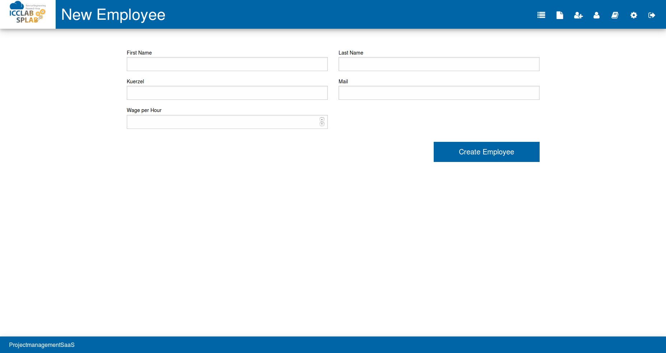

To create a new employee, click on the button. You then must fill in all the fields. Make sure the kuerzel and the e-mail address are correct. The new employee will get an e-mail with his user credentials and will be requested to change the auto generated password.

## 3.5. My Profile

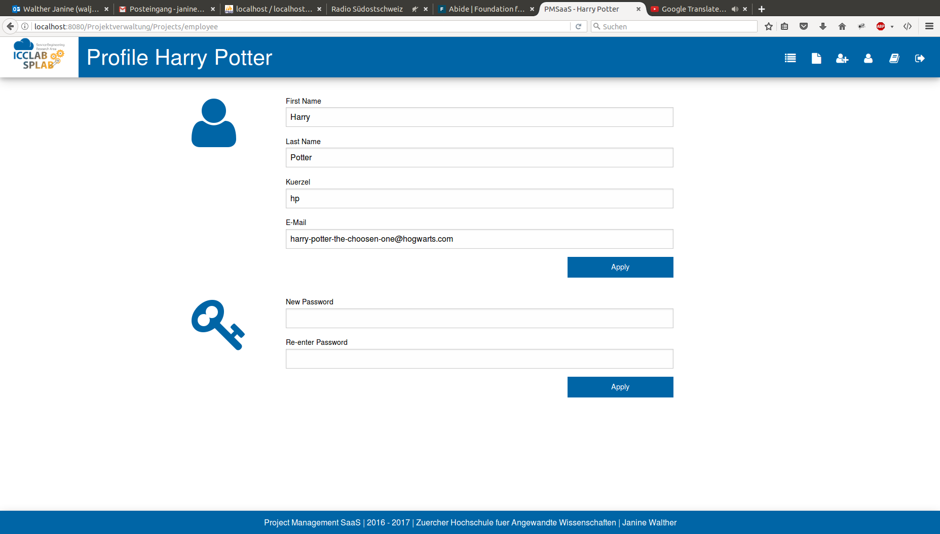

If you want to change your name, e-mail or password you can do so at My Profile.  
Click on the button and you see your information and a section where you can enter a new password.

## 3.6. Admin

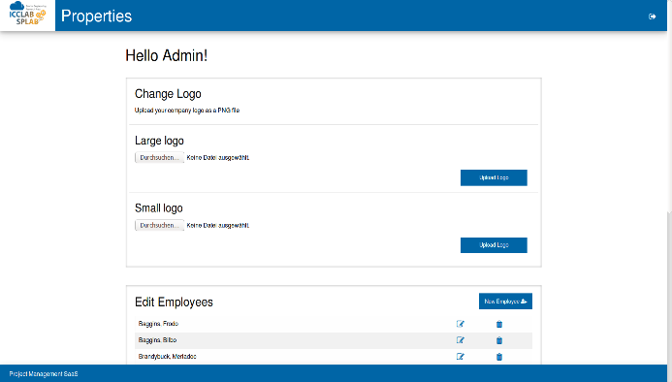

The admin can do administrative things like changing logos and delete projects.

### 3.6.1. Change Logo

To change the company’s logo, you must upload a PNG file. The tool will not accept other data types. You must upload two versions of your logo: a small and a large one. The large one is used for the login and logout page, the small one for the header on most other pages.

### 3.6.2. Edit Employees

On the Edit Employees panel, you can create new employees, edit and delete them. Please notice that you can’t delete users that are already involved in projects. If you want to know how to create a new employee look at . If you want to edit the user click on . You will see the employee information and can make changes. If you want to delete the user, you can click on . If the user has some projects, booked hours or expenses you cannot delete him.

### 3.6.3. Edit Projects

If you want to archive, restore or delete projects, you can do so on the Edit Projects panel. You see the project’s name and its owner. Click  to archive the project and  to restore it. If you want to delete it click on .